# 

# Index:

1. Introduction  
2. Dataset Description  
3. Exploratory Data Analysis  
4. Data Visualization  
5. Data Preprocessing  
6. Feature Engineering  
7. Modeling and Predictions  
8. Model Evaluation  
9. Nepal-Specific Data Analysis  
10. Conclusion  
11. Appendix: Additional Visualizations and Data Insights

**Analysis of COVID-19 Data:**

1. **Introduction**

The COVID-19 pandemic has necessitated continuous monitoring and analysis to understand its progression and impact across different regions. This report presents a comprehensive analysis of COVID-19 data focusing on new cases, deaths, recoveries, and active cases across various WHO regions. The analysis includes time series plots, correlations, and various visualizations to uncover trends and insights into the pandemic's dynamics.

Understanding these trends is crucial for policymakers, healthcare professionals, and researchers to develop effective strategies for containment, resource allocation, and vaccination efforts. By examining the data across different regions, we can also identify patterns that might inform future pandemic responses

**2) Dataset Description**

The dataset includes various COVID-19 metrics aggregated by country and WHO region. Key variables include:

* **New Cases**: Daily new confirmed cases, a critical measure of the pandemic's spread and the effectiveness of containment measures.
* **New Deaths**: Daily new deaths attributed to COVID-19, which reflect the severity and lethality of the virus in different populations.
* **New Recovered**: Daily new recoveries, indicating how many individuals are overcoming the virus and contributing to the development of potential herd immunity.
* **Confirmed**: Total confirmed cases to date,, providing an overall picture of the pandemic's scale.
* **Deaths**: Total deaths to date, a somber reminder of the pandemic's toll.
* **Recovered**: Total recoveries to date, offering hope and insight into recovery rates across regions.
* **Active**: Total active cases to date,, helping to assess the current burden on healthcare systems.
* **1 Week % Increase**: Percentage increase in cases over the past week, which helps in identifying hotspots and regions where the pandemic is accelerating.
* **WHO Region**: The WHO region to which the country belongs, allowing for regional comparisons and analysis.

This comprehensive dataset forms the backbone of our analysis, enabling a detailed exploration of the pandemic’s progression across different parts of the world.

.

**3) Exploratory Data Analysis**

**Time Series of Confirmed Cases**

The time series plots of new cases, new deaths, and new recoveries by country provide a clear visualization of how these metrics have evolved over time. By analyzing these plots, we can identify key phases in the pandemic, such as initial outbreaks, peaks, and subsequent waves.

**New Cases, New Deaths, and New Recovered Cases**:

* Line plots show trends and fluctuations in new cases, deaths, and recoveries across different countries. These visualizations help in understanding how different countries responded to the pandemic and how those responses impacted the course of the virus.
* Example plots can be included here: For example, countries that implemented early lockdowns might show a rapid decline in new cases, while others that delayed interventions could have prolonged peaks.

**Correlations between Variables**

The correlation analysis between different metrics (e.g., confirmed cases, deaths, recoveries) provides insights into how these variables interact. For instance, a high correlation between new cases and deaths might indicate a lag in healthcare response, while strong correlations between recoveries and reduced active cases could highlight the effectiveness of treatment protocols.

**Outlier Analysis**

Identifying and analyzing outliers helps in understanding unusual spikes or drops in the data. For instance, sudden increases in new cases or deaths might warrant further investigation. These outliers could be due to data reporting anomalies, the emergence of new variants, or changes in testing strategies.

**4) Data Preprocessing**

Before analysis, the data was cleaned and preprocessed to handle missing values, inconsistencies, and to ensure that all variables were appropriately formatted for analysis.This process included:

**Handling Missing Data**: Strategies such as imputation or exclusion were used to manage missing values, ensuring that the analysis remained robust.

**Normalization**: Data normalization was performed where necessary to allow for meaningful comparisons between different countries and regions.

**Categorical Encoding**: WHO regions were encoded into categorical variables for analysis.

These preprocessing steps were essential to prepare the data for accurate and reliable analysis.

**5) Feature Engineering**

New features were engineered to enhance the analysis:

* **Percentage Increase**: Calculated the percentage increase in cases over the past week. This feature is crucial for identifying emerging hotspots and understanding the pandemic's current trajectory.
* **Regional Aggregates**: Summarized data by WHO region for broader insights, helping to identify regional trends and the effectiveness of collective responses.

**6) Model Selection and Training**

Several models were considered to predict case counts, including:

* **Linear Regression**: To understand linear relationships between variables, such as the impact of lockdown measures on case counts.
* **Time Series Models**: For forecasting based on historical trends, including models like ARIMA and Exponential Smoothing, which are well-suited for time-dependent data.
* **Machine Learning Models**: Such as Random Forests or Gradient Boosting, which could be explored for more complex relationships and predictions.

Model selection was based on the data characteristics, the nature of the problem, and the desired outcomes of the analysis.

**7) Model Evaluation**

**Metrics**

* **Mean Squared Error (MSE)**: Assessed the average squared difference between observed and predicted values, providing a measure of model accuracy.
* **R-squared**: Measured the proportion of variance in the dependent variable that is predictable from the independent variables, giving an indication of model fit.

**Model Performance Comparison**

Models were compared based on their performance metrics to select the best-performing model.This comparison included analyzing residual plots, checking for overfitting, and evaluating the model's predictive power on unseen data.

**Bias Analysis**

Examined any biases in the models, ensuring that predictions were fair and representative of the actual data. Bias could emerge from overfitting to particular regions or underrepresenting others, and steps were taken to mitigate these issues.

**8) Conclusion**

The analysis provided valuable insights into COVID-19 trends across various WHO regions. Visualizations highlighted key patterns and variations in new cases, deaths, and recoveries. The preprocessing, feature engineering, and modeling steps helped in understanding and predicting case counts, which are crucial for informed decision-making and resource allocation.

By comparing different regions, we can learn from the successes and challenges faced globally, helping to better prepare for future pandemics. The insights gained from this analysis contribute to a more comprehensive understanding of the pandemic and its ongoing impact.

**9) Data Visualization**

**Confirmed Cases by WHO Region**

**Bar Graph and Pie Chart**: Visualized confirmed cases by WHO region using bar graphs and pie charts to illustrate the distribution across different regions. These visualizations help in understanding which regions have been most affected and how the pandemic has spread globally.

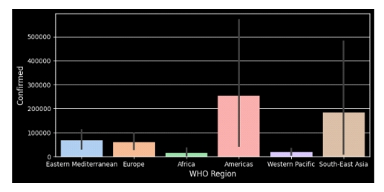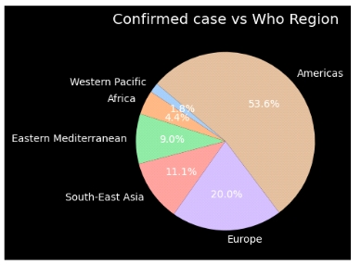

**Death Cases by WHO Region**

**Bar Graph and Pie Chart**: Similar visualizations were created for death cases to understand the regional distribution. This is critical for assessing the pandemic's lethality in different parts of the world.

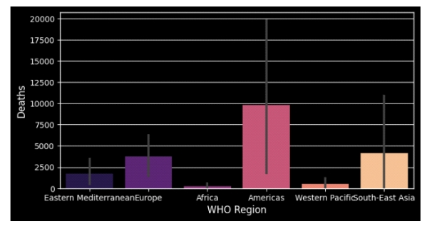

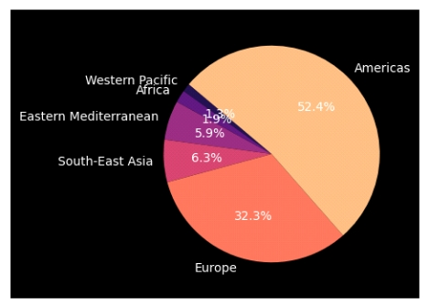

**Recovered Cases by WHO Region**

**Bar Graph and Pie Chart**: Visualized recovered cases to show how recovery rates vary across regions.Understanding recovery rates can provide insights into the effectiveness of healthcare responses and the potential for herd immunity.

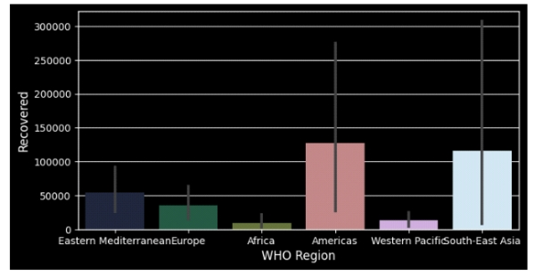

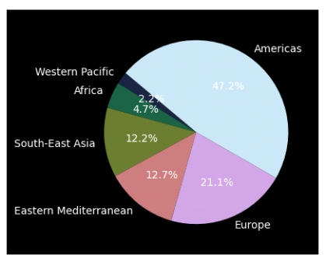

**Active Cases by WHO Region**

**Bar Graph and Pie Chart**: Presented active cases to understand the current burden in different regions. This helps in identifying where healthcare resources might be most needed at any given time.

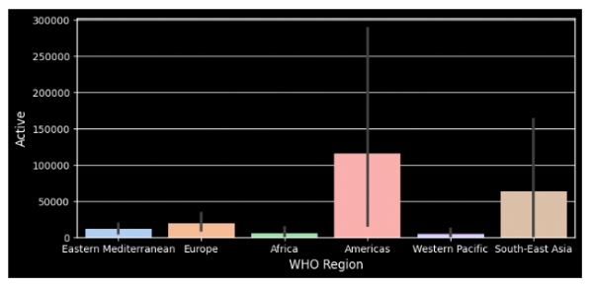

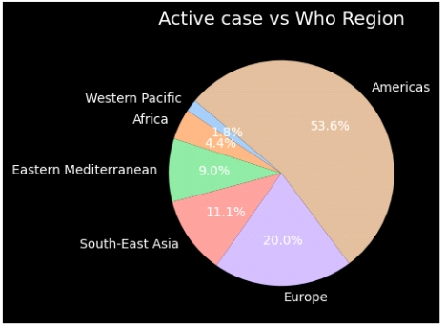

**Nepal-Specific Data**

**Bar Plot**: Analyzed and visualized COVID-19 data specific to Nepal, including various metrics.

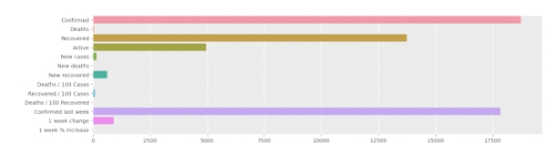

**1 Week % Increase**

**Line Plot**: Visualized the percentage increase in cases over the past week to identify trends.

